Java with DSA-Day9

Valid Stack Operation:
import java.util.*;
class valid{
public static void main(String[] args){
int n=5;
int pushed[]={1,2,3,4,5};
int popped[]={4,5,3,2,1};
int j=0;
Stack<Integer> s=new Stack<>();
for(int i=0;i<n;i++){
s.push(pushed[i]);
if(s.peek()==popped[j]){
s.pop();
j++;
}
}
for(int i=j;i<n;i++){
if(s.peek()==popped[j]){
s.pop();
j++;
}
}
if(s.isEmpty()){
System.out.print("true");
}
else{
System.out.print("False");
}
}
}
Using While Loop:
import java.util.*;
class valid{
public static void main(String[] args){
int n=5;
int pushed[]={1,2,3,4,5};
int popped[]={4,5,3,2,1};
int j=0;
Stack<Integer> s=new Stack<>();
for(int i=0;i<n;i++){
s.push(pushed[i]);
while(!s.isEmpty() && s.peek()==popped[j]){
s.pop();
j++;
}
}
if(s.isEmpty()){
System.out.print("true");
}
else{
System.out.print("False");
}
}
}
Output:
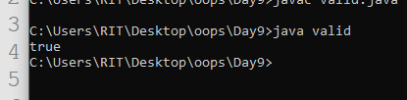
Valid palindrome using Stack:
import java.util.*;
class pali{
public static void main(String[] args){
String str="A man,a Plan,enalp, Ana:ma";
str=str.toLowerCase();
StringBuilder name=new StringBuilder();
for(int i=0;i<str.length();i++){
char ch=str.charAt(i);
if(Character.isLetter(ch)){
name.append(ch);
}
}
Stack<Character> s=new Stack<>();
for(int i=0;i<name.length();i++){
char ch=name.charAt(i);
s.push(ch);
}
for(int i=0;i<name.length();i++){
char ch=name.charAt(i);
if(s.pop()!=ch){
System.out.println("False");
return;
}
}
if(s.isEmpty()){
System.out.println("True");
}
}
}
Output:
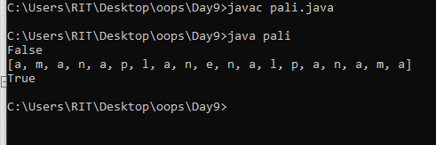

Queue Operations:
import java.util.*;
class Main{
public static void main(String[] args){
Queue<Integer> q=new LinkedList<>();
q.add(10);
q.add(20);
q.add(30);
q.add(40);
q.add(50);
System.out.println("After Insertion: ");
System.out.println(q);
q.offer(60);
q.offer(15);
q.remove();
q.poll();
System.out.println(q.peek());
System.out.println(q.element());
System.out.println(q.contains(50));
System.out.println(q.size());
System.out.println(q.isEmpty());
System.out.print(q);
}
}

Output:
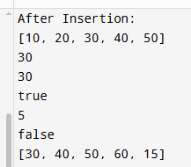

ArrayDequeue Operation:
import java.util.*;
import java.util.ArrayDeque;
class deque{
public static void main(String[] args){
ArrayDeque<Integer> q=new ArrayDeque<>();
q.addFirst(10);
q.addFirst(20);
q.addLast(30);
q.addLast(40);
q.offerFirst(50);
q.offerLast(60);
System.out.println("After Insertion: ");
System.out.println(q);
q.removeFirst();
System.out.println("After Remove: ");
System.out.println(q);
q.pollFirst();
System.out.println("After Remove: ");
System.out.println(q);
q.removeLast();
System.out.println("After Remove: ");
System.out.println(q);
q.pollLast();
System.out.println("After Remove: ");
System.out.println(q);
System.out.println("First Element: "+q.getFirst());
System.out.println("Last Element: "+q.getLast());
System.out.println("First Element: "+q.peekFirst());
System.out.println("Last Element: "+q.peekLast());
System.out.println(q.contains(50));
System.out.println("Size: "+q.size());
System.out.println("isEmpty?: "+q.isEmpty());
System.out.print(q);
}
}

OutPut:

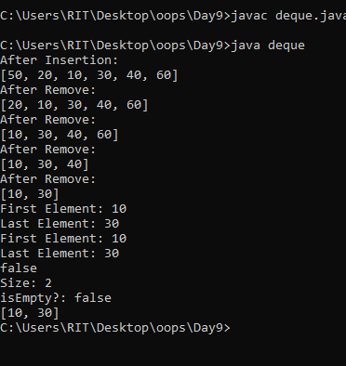

Priority Queue Operations:
import java.util.Collections;
import java.util.PriorityQueue;

class Main{
public static void main(String[] args){
PriorityQueue<Integer> q=new PriorityQueue<>();
q.add(70);
q.add(65);
q.add(30);
q.add(25);
q.add(50);
q.add(49);
System.out.println("After Insertion: ");
System.out.println(q);
PriorityQueue<Integer> pq=new PriorityQueue<>(Collections.reverseOrder());
pq.add(10);
pq.add(20);
pq.add(30);
pq.add(40);
q.offer(50);
q.offer(60);
System.out.println("After Insertion: ");
System.out.println(pq);
}
}
Output:

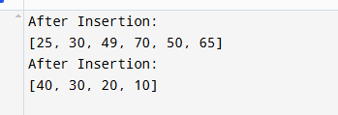

Reverse the k element in an array:

import java.util.*;
import java.util.ArrayDeque;
class Arr{
public static void main(String[] args){
Scanner sc=new Scanner(System.in);
System.out.println("Enter the no of Elements: ");
int n=sc.nextInt();
System.out.println("Enter the array Element: ");
int[] arr=new int[n];
for(int i=0;i<n;i++){
arr[i]=sc.nextInt();
}
System.out.println("Enter the No of Elements to reverse:");
int k=sc.nextInt();
ArrayDeque<Integer> pq=new ArrayDeque<>();
for(int i=0;i<k;i++){
pq.addFirst(arr[i]);
}
for(int i=k;i<arr.length;i++){
pq.addLast(arr[i]);
}
System.out.println(pq);
}
}
Output:
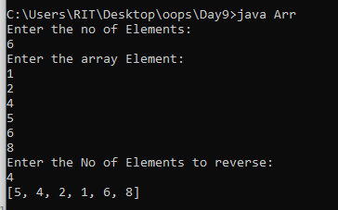
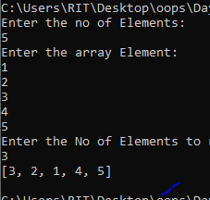

Set:
HashSet:
import java.util.*;
class Main{
public static void main(String[] args){
Scanner sc=new Scanner(System.in);
HashSet<Integer> hs=new HashSet<>();
hs.add(10);
hs.add(20);
hs.add(30);
hs.add(40);
System.out.println(hs);
hs.remove(30);
System.out.println(hs);
System.out.println(hs.size());
System.out.println(hs.isEmpty());
}
}

Output:
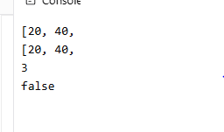

LinkedHashSet:

